Research Process Overview
Date |  | Project #: | FLOC: | Principal Investigator (PI):
Lab Safety Representative: |  |  |  | HSE Representative:
Other Review Team Members: |  |  |  | Division:
Reason for POSHER: |  | - Initial Review New Chemical or Process Response to Audit Lab Modification
Brief Overview of Research/ Laboratory Process:

Brief Description of Primary Hazards:
IMPORTANT! Please contact:
- Institutional Biosafety and Bioethics Committee at IBEC@kaust.edu.sa if your research involves biological materials/ biological agents, plant and plant pathogens, genetically modified organisms and/or recombinant/synthetic nucleic acids (r/s N/A), or human subject/materials.
- Institutional Animal Care and Use Committee at IACUC@kaust.edu.sa if your research involves animals (laboratory and/or field) regardless of the acquisition source (vertebrates and/or invertebrate animals).
- Institutional Radiation Safety Committee at IRSC@kaust.edu.sa if your research involves radioactive substances, uranyl acetate, uranyl nitrate, uranium salts, sealed radioactive sources, equipment with X-ray source, SEM/TEM, or other ionizing radiation source.
- HSE and use Laser Registration Form if your research involves the use of Class 3B, or Class 4 lasers
- Please contact hse@kaust.edu.sa to setup a chemical inventory in the HSE management system.
Facilities Services Requirements Review
What Type of Facilities Services/Equipment Do You Need? | Yes | No | If Services Don’t Exist, Then List Actions Required | Action Owner
- House Compressed air?
- House Vacuum?
- House DI/RO Water?
- Local process cooling water?
- Local (process specific) gas sources?
- Chemical Fume Hood?
- Need dedicated ventilation exhaust for toxic chemicals or high concentrated acids?
See POSHER Guide for more details
- Other local exhaust ventilation (LEV) e.g. snorkels, canopy, enclosures?
- Ventilation band assigned. |  |  | Low 2-4 ACH  Moderate 4-6 ACH  High 8-10 ACH  Consult with HSE for more information about Lab Ventilation
- Will a biosafety cabinet be required? If yes, initial and annual certification is required. If relocating the biosafety cabinet from another location, the cabinet should be decontaminated and recertified. Contact the Biosafety Specialist for more information.
  - Make initial determination of BSC type
8.2 Any modification for the BSC required to accommodate equipment? (e.g., sash modified for microscope use, etc.) NOTE: PI responsible for additional cost
- Any additional special large equipment needed? (e.g. lyophilizer, flow cytometer, autoclave, etc. NOTE: Please make every effort to include ALL needed equipment
- Plant growth chamber?
- Cold Room?
- Electromagnetic Interference (EMI) protection?
12.1 Is this process likely to be a source of EMI to others?
- Vibration protection?
- Will hazardous gases (flammable, toxic, corrosive, etc.) be used? Describe:
- Will non-hazardous compressed gases used? Describe:
- Are there special electrical requirements for your equipment (UPS Voltage, Amperage, Phase or Plug Connections)?
- Are there specific labels/standard signage required beyond basic door lab signage? (i.e. Laser, X-ray, radioactive material, biohazard, etc)
17.1 Biohazard
17.2 Laser
17.3 Radiation source
- Are there any plans for scale up operations? Pilot plants

Hazard Identification
Which Type of Hazards Exist in Your Work? | Yes | No | Comments | If “Yes”, Go to Section:
Chemical Hazards (Solids, Liquids or Gases) |  |  |  | A
Biological Hazards (infectious agents, biological toxins, cell and tissue culture, R/SNA, environmental samples, animals, etc.) |  |  |  | B
Ionizing Radiation Hazards (Radioactive Material, Radiation equipment) |  |  |  | C.1
Non-ionizing Radiation Hazards (Lasers, UV, RF, magnetic fields, etc.) |  |  |  | C.2
General Equipment/Process Hazards (e.g. high temp. or noise, mechanical) |  |  |  | D

Section A – Chemical/Gas Hazard Review
Section A.1 – Hazardous Chemical/Gas Use Information, based on SDS data and OSHA definitions of hazardous chemicals, 29CFR 1910.1200
https://www.osha.gov/dsg/hazcom/ghd053107.html

List: Main hazardous chemicals, biological agents, and by-products associated with this process that present a significant health hazard according to:  GHS: labels with these pictograms  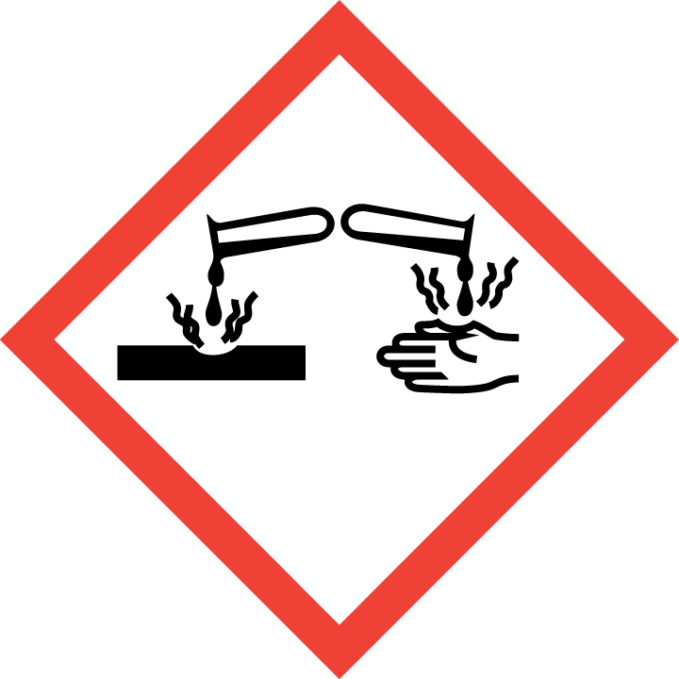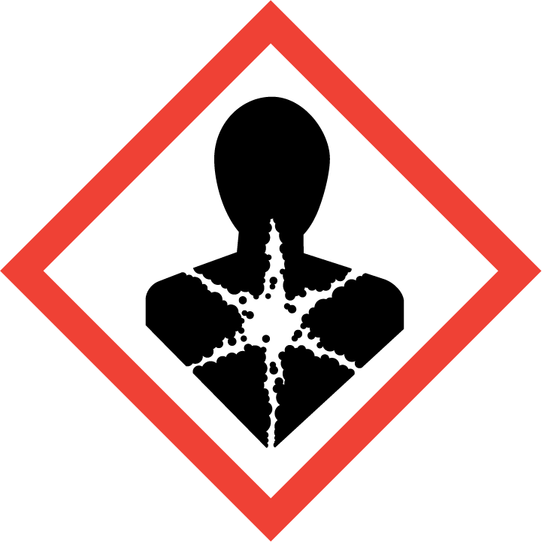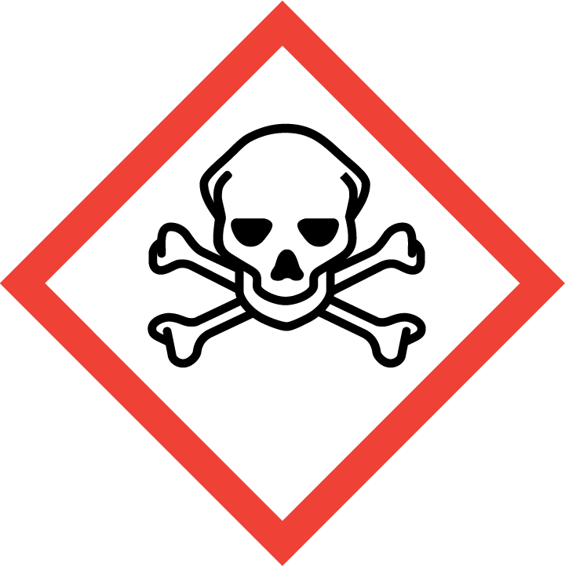  NFPA: rating of 3 or 4 in the blue square of the diamond  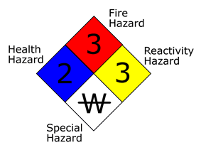 | Identify:  Solid  Liquid  Gas |  |  | Estimate:  Maximum monthly/ annual usage rates |  | Indicate:  Storage capacity requires, Estimated use for storage | Estimate amount to:  Drain  Exhaust  Hazardous waste | Indicate if:  Toxic  Pyrophoric  Flammable/Combustible  Oxidizer  Dust source  Corrosive  Odour detectable  Volatile organic compound  Radioactive  Asphyxiant  Carcinogenic  Reproductive toxin  Teratogen  Mutagen  USA DOD chemicals of concern  Controlled substances
Section A.2 - Chemical Hazard Review Questions/Action Items
Chemical Process Details |  | Yes | No |  | Engineering Controls / Details |  |  |  | Action Owner
Are there pressurized process or system liquids? (i.e. pumped chemical lines, hydraulics) Describe:
Are there pressurized process gas systems? Describe:
Are external chemical delivery systems required (liquids)? Describe:
Are there open liquid chemical baths (wet bench)?
Beyond standard Right to Know (SDS), are communications to lab users working with individually regulated chemicals required? (e.g. Formaldehyde, asbestos, methylene chloride, lead, mercury)
Is a Standard Operating Procedure for gas connection/purging or chemical filling required?
Amounts larger than 3 liter to be handled in a single experiments?
Acids to be heated or concentrated?
Large amount of solvents to be concentrated?
Perchloric acid to be heated?
Toxic gases to be used? Estimated amount and concentrations
Flammable gases to be used? Estimated amount and concentrations
Does this lab required additional controls such as TGM systems, gas scrubbers and gas cabinets, VMB, manifolds?

Section B – Biological Hazard Review
Biological Process Details | Yes | No | Engineering Controls / Details | Action Owner
Will you be working with materials that require BSL-1 facility? |  |  | If yes, please list if known
Will you be working with materials that require BSL-2 facility? |  |  | If yes, please list if known
Will you be working with materials that require BSL-3 containment? |  |  | If yes, please list if known  Additional Task: Complete BSL-3/ABSL-3 Project Application Form.
Will your research involve the following:  - Human samples: cell lines, blood, unfixed tissues/organs, bodily fluids  - Bloodborne Pathogens |  |  | If yes, contact Institutional Biosafety and Bioethics Committee before working with materials.  Additional Tasks: Complete Bloodborne Pathogens Training, Exposure Control Plan and Hepatitis B Vaccination Form.
Will your research involve:  - Recombinant/synthetic nucleic acid  - Risk Group 2 or 3 pathogens  - Viral vectors  - Biotoxins  - Genetically modified organisms  - Plants  - Gene editing technology (CRISPR)  - Potentially infectious environmental samples  - Nanotechnology |  |  | If yes, contact Institutional Biosafety and Bioethics Committee before working with materials.
Will your research involve animals or animal materials? |  |  | If working with animals, contact Institutional Animal Care and Use Committee before starting work.  If working with animal materials, contact Health, Safety and Environment before starting work.  Additional Task: Complete Animal Exposure Medical Evaluation.
Will you be using an autoclave to treat your biohazardous waste? |  |  | Additional Tasks: autoclave must be tested using biological indicators, contact Health, Safety and Environment for advice on type of biological indicators; contact Laboratory Equipment Maintenance for advice on type of autoclaves.
Will your research involve field work? |  |  | Additional Task: Complete Field Safety Plan and Field Safety Awareness Training
Will tissues or samples will be transferred out of KAUST?

Transportation of biological samples to KAUST?
Respiratory protection needed while handling biological agents?

Section C – Radiation Hazard Review
Section C.1 – Ionizing Radiation Hazards
Radiation Process Details | Yes | No | Engineering Controls / Details | Action Owner
Does this process involve the use or assemble of ionizing radiation devices? (i.e. Radiation Producing Equipment)? Examples: accelerators, X-ray sources, X-ray producing device: electron microscopes (SEM/TEM), RBS, XRD, XRF, EBL, XPS, CT, irradiator? If yes, you are required to:
- Notify the RSO and request a radiation safety risk assessment (before purchasing or assembling of the radiation equipment)
- Notify the IRSC and apply for Radiation Use Authorization

Does this process involve the use unsealed radioactive compounds? Such as H-3, P-32, P-33, C-14, etc.
If yes, you are required to:
- Notify the RSO and request a radiation safety risk assessment
- Notify the IRSC and apply for Radiation Use Authorization
- Notify the Radiation labeling Core Lab (RLCL)

Does this process involve the use of sealed radioactive sources or equipment containing radioactive source such as LSC, GC-ECD? If yes, you are required to:
- Notify the RSO and request a radiation safety risk assessment.
- Notify the IRSC and apply for Radiation Use Authorization before purchasing the radioactive source or the equipment.

Does this process involve the use of uranium compounds such as uranyl acetate and uranyl nitrate? If yes, you are required to:
- Notify the RSO and request a radiation safety risk assessment
- Notify the IRSC and apply for Radiation Use Authorization before purchasing the material.

Section C.2 – Non-ionizing Radiation Hazards
Radiation Process Details | Yes | No | Engineering Controls / Details | Action Owner
Does any equipment present a source of RF/Microwave energy which can present a hazard in normal use or in service? If yes, are there interlocks or other user protection?
Does the equipment involve the use of Class 1M, Class 2M, Class3R lasers? If yes, are the following requirements in place for labelling:
- “Caution LASER”
- Hazard class
- Power of the LASER
- Type of LASER
- Wavelength
- Pulse duration if applicable
Note: For Class 1M, 2M, and Class 3R LASER – Door should be labelled with the same info as the LASER label.
Does the equipment involve the use of Class 3B or Class 4 lasers? If yes, then are the following requirements in place?
- Have all users attended Laser Safety training offered by HSE?
- Has the laser been registered with HSE?
- Is the laser-controlled area (LCA) established and laser hazard evaluation (LHE) finalized
- Is there appropriate protection from the direct/scattered beam hazards (i.e. rated enclosure, rated beam stopper, rated barriers, reflection)
- Is there appropriate eye (and skin if required) protection available?
- Is there appropriate protection from the non-beam hazards (i.e. electrical, lasing medium; gas/liquid, target interaction air contaminates, fire; ignition of flammable material)
- Is there appropriate entryway protection and access control for the laser work area?
- If excimer lasers are present, is Cl or F gas properly supplied and vented? (e.g. gas cabinets for cylinders and sufficient exhaust for the laser?)
Are there any other sources of non-ionizing radiation that require controls to ensure personnel safety? (e.g. magnetic fields >5 gauss, UV, high intensity light sources, etc.)

Section D – General Equipment/Process Hazard Review
General Equipment/Process Issues | Yes | No | Engineering Controls / Details | Action Owner
Are there processes or equipment that should have “off hour” use restrictions for normal use or service? Describe and explain.
Should the equipment or process have buddy-system requirements for normal use or service? Describe and explain.
Are you using any syringes and needles?
Are there noises over or approaching 85db (e.g. sonicators and other equipment)? If yes, then hearing protection and appropriate signage will be required.
Are there exposed sources of electrical voltage?
Are there exposed hot surfaces?
Are you using an autoclave?
Is a written standard operating procedure (SOP), including start up / shut down of equipment, available?
Are there special hazards associated with start up or shut down?
Is equipment specific training required for users? How are training records maintained?
Is personal protective equipment required for the user/operator?
Is maintenance required while the equipment is on? Interlocks?
Is mechanical guarding required? (cutting devices, grinders, pinch points, etc)
Are there vibration sources? Vibration mitigation?
Are there ergonomic concerns with the process or equipment?
Is a local process exhaust required? Why?
Will the process involve the production of chemical waste, regulated medical waste, biological waste, radioactive waste, or other hazardous waste? If yes, then how will it be collected and disposed of (red bags, sharps, burn boxes)? Have personnel been trained accordingly?
Will the process involve the shipping or transfer of any hazardous materials (e.g. dry ice, samples in formaldehyde or ethanol)? If yes, have all shippers of hazardous material been trained and have received a certification from HSE to show compliance with export controls? Contact HSE for more information.

Training Assessment
Minimum Training Requirements | Yes | No | Comments/Action Items | Action Owner
The following training is required for your lab regardless of the type of process or research utilized.
- Laboratory Safety Training
- Hazardous Waste Training
- Emergency Incident Preparedness Training
Additional Training Requirements | Yes | No | Comments/Action Items | Action Owner
Identify the additional training required for laboratory personnel based on the hazards involved and listed above. For example, Radiation Safety Training, Laser Safety Training, Biosafety training etc.
Please review the available HSE trainings: https://hse.kaust.edu.sa/training/research-safety-training or contact hse@kaust.edu.sa for a list of available safety courses
Additional comments regarding safety training:

Final Review & Assessment

Emergency Requirements | Yes | No | Engineering Controls / Details | Action Owner
Are eyewash / showers required?
Are chemical spill kits required?
Are biohazard spill kits required? If YES, please contact researchsafety@kaust.edu.sa (recommendations for basic kit contents). There is no need to buy a pre-made biohazard spill kit.
Is there a First Aid kit(s) available?
Are there any special first aid kit antidote/cream required? (e.g. Calcium gluconate gel if Hydrofluoric Acid used in lab)
Would field research be part of the group activities? |  |  | Prior to embarking on any trip, a Field Research Leader must be designated to organize and submit a Field Safety Plan. The Field Research Leader should prepare as far in advance as possible by consulting with the Center Director (where appropriate), Coastal and Marine Resources Core Lab (for all sea-based field research), Government Affairs (for trips within Saudi Arabia and the region), and HSE.  More information and resources available at:  https://hse.kaust.edu.sa/services/field-research-safety-program
Is local fire suppression required?
Specialized fire suppression systems?
Is Toxic Gas Monitoring Required?
Are Local Alarms/Indications Required?
Will changes be required to emergency response protocol?
Are there any special lab shutdown procedures?

Risk Assessment Questions | Yes | No | Comments/Action Items | Action Owner
Other engineering controls necessary to implement?
Other administrative controls to implement?
Additional PPE required?
Are you familiar with the HSE Lab Safety Manual?
Lab Safety Specific Plan completed?
If yes, has anything changed?
Has the lab space completed the lab readiness checklist?
Any recent accidents or near misses?
Do you have any safety concerns or issues you would like to discuss?

Based on the chemicals, amounts and research conducted in the space does this lab required dedicated fume hoods or dedicated exhaust systems? |  |  | Check POSHER guide for list of chemicals
Based on HSE risk matrix for laboratories this space, project, laboratory modification, new lab or spaces has been classified as: |  |  | Low Risk: Risk rating resulting lower than 20 of probability of events and hazard levels  High Risk: Risk rating result equal or higher than 20 of probability of events and hazard levels
Summary of Attachments: List all documents and SOPS that are or will be provided in association with the POSHER
Examples include: Material Transfer Agreement (MTA), Permits for Biological Materials/ Biological Agents, Biological Risk Assessments, Biological Agents/ Biological Materials Inventory, Chemical Inventory, IBEC and/or IACUC Protocol Application #s, Radiation Permit, Equipment Operating Procedures including emergency shut down start up, Equipment Information Sheet, Standard Operating Procedures, BBP-ECP, etc.

Conclusion

Given what is currently known and assuming all open actions are closed, can this research process be safely conducted at KAUST? | Yes |  | No

Action Registry
Issue | Action Required | Action Owner | Due date | Completed

I have reviewed this POSHER form together with RST safety officer and concur with the content and conclusion.
Add some more here…

Name, Signature, Date

Lab Representative:
PDEC Representative:
FM Representative:
HSE Representative:

