Purpose
The purpose of this procedure is to establish safe and correct means for collecting, preparing, and packaging radioactive waste from KAUST laboratories.

Scope
This procedure applies to all KAUST research spaces where radioactive substances are used.

Definition
Aqueous Waste: | Aqueous radioactive liquids are those in which the solvent and solute are both water-based with a pH between 6 and 10 and may not contain hazardous chemicals. Liquid waste containing toxic, corrosive, flammable, or reactive chemicals must be disposed of as mixed radioactive and chemical waste. Appendix 1 shows a non-exhaustive list of radioactive compounds that can be disposed as aqueous waste.
Combustible Solid Waste: | Any solid waste, generally composed of paper, plastic, gloves, i.e. general lab trash, containing less than 0.5% by volume of free standing liquid.
Half-Life: | The time required for one-half of the atomic nuclei of a radioactive sample to decay (change spontaneously into other nuclear species by emitting particles and energy). In other words, the probability of a radioactive atom decaying within its half-life is 50%.
Lead Pigs: | Lead shielding containers are used for shipping some radionuclides.
Liquid Scintillation Vials (LSC): | Scintillation vial waste includes vials generated during the liquid scintillation counting process, that contain radioactive material and scintillation cocktail. Vials are made of plastic or glass containers of 20 ml capacity or less.
Non-Aqueous Waste: | Non-aqueous waste (also called organic liquid waste) contains radioactive and hazardous waste such as liquid scintillation cocktails (e.g. xylene, toluene, or other harmful chemicals present in liquid scintillation cocktails etc.), organic solvents (e.g. corrosive organics, oil, etc.), toxic metals (excluding uranyl acetate), etc. Non-aqueous waste is generally defined as a liquid that is not soluble, or readily dispersible in water.
Radioactive Waste | Any material that has come in contact with radioactivity and may be contaminated.
Radioactive Waste Accumulation Log: | Log of all radioactive waste disposed in a waste container. This must be kept up to date (Appendix 4).
Radioactive Waste Tag: | Tag that must be added once the waste bin is closed and ready for collection (Appendix 2).
Radioactive Waste Pick-up Form | This form is used to list all ready-for-pickup containers and must be submitted to the RSO when radioactive waste pick-up is requested.
Radioactivity Stock and Waste Record | A form that is used to account for stock usage and generated waste
Radiation Safety Officer (RSO): | Radiation Safety Specialist who is licensed by the Saudi Competent Authority (Nuclear and Radiological Regulatory Commission) and responsible for the university’s compliance with the ionizing radiation regulations within Saudi Arabia.
Sealed Sources | A sealed source is defined as radioactive material that is encapsulated, radioactive sealed sources include the following:  - Calibration and check sources.  - LSC std and quench sources
Sharps Waste | Sharps are objects, such as broken glass, needles, syringes, scalpel blades, glass pipettes, plastic pipette tips, etc., that have or may have been contaminated with radioactive materials and that can cause injury and/or puncture or cut through the waste container liner.
Stock Vials | Radioactive liquid stock vials are fluids that are generally in small quantities and high concentrations of radionuclides.

Personal Protective Equipment (PPE)
Standard Laboratory PPE, as described in the Lab Safety Manual, must be worn. This includes lab coat, safety glasses, gloves, closed toe-shoes and covered legs. In addition, users who have been required by RSO to wear a dosimeter must wear the dosimetry badges or finger-ring they have been issued.

General Information
- All radioactive waste must be segregated by radionuclide (i.e., each radionuclide must have its own dedicated waste container), except solid waste of H-3 and C-14 which can be mixed in the same waste container.
- Do not dispose of non-radioactive material as radioactive waste. Survey potentially contaminated items, if they are less than 2 times background and 100 DPM, they are not radioactive. Remove or deface any radiation symbols or markings and dispose as regular trash. This includes packing materials, but not stock vials or lead pigs.
- No liquid containing radioactive materials, may be disposed of through the laboratory sanitary sewer system.
- Aqueous liquid waste solutions should be adjusted to a pH between 6 and 10.
- For dry solid waste, it is recommended that individual waste bins are created for each experiment. These small dry solid waste bags can then be combined into a large waste bag in the accumulation area.
- All radioactive waste must be bagged, labeled, and placed in the laboratory designated waste accumulation area prior to requesting a waste pick-up.
- Once activity has been drawn from the stock solution it should NOT be decay corrected for waste purposes (i.e. always base waste estimation on initial activity drawn from stock solution).
- Researchers must use plastic scintillation vials and non-hazardous biodegradable scintillation media, unless otherwise specifically authorized by the Radiation Safety Office.
- Solid and liquid waste containers, radioactive waste bags, and radioactive waste labels can be purchased via the Chemical Warehouse.
- The RSO will provide guidance for radioactive materials that do not fit established disposal processes. Items may include contaminated equipment, legacy materials, and materials with multiple hazards.
- Radioactive Waste Tag must only be used once a bag or carboy is closed and ready to be disposed.

Methods for minimizing the volume of the radioactive waste
- Separating radioactive from non-radioactive material
- Segregating radioactive waste by radionuclide and physical form.
- Using short-lived isotopes
- Performing small scale experiments
- Where possible, not mixing radioactive materials with chemicals or biohazardous materials
- Rendering the materials non or less hazardous in the last steps of the experiment
- Emphasizing the importance of reducing the source and generation of radioactive waste

Required Items
- Plastic carboy (2L to 10L)
- Transparent bin bag/liner (4 mil thick plastic liner)
- Radioactive Waste Tag (Appendix 3)
- Secondary container labelled with a radiation trefoil sign.
- Radioactive Waste Accumulation Log (see Appendix 4)
- Radioactive Waste Pick-up Request From

Liquid Radioactive Waste

Procedure
- Radioactive aqueous waste must be segregated by radionuclide, i.e., each radionuclide must have its own waste carboy/bottle.
- Liquid radioactive waste must not be disposed into the sanitary sewer.
- New liquid waste carboy/bottle must be labeled with the radioactive trefoil sign on two opposite sides. A label indicating the radionuclides and “Aqueous Waste” must be fixed on the outer side of the container or alternatively written with a marker pen on the carboy/bottle. The associated Radioactive Waste Accumulating Log for that waste carboy/bottle must also be created and kept near or taped to the carboy/bottle.
- Aqueous waste must not contain any viable biological agents. All biological agents must be inactivated via chemical disinfection procedures (i.e., no autoclaving or steam sterilization).
- Liquids containing radioactive materials must be poured carefully into plastic carboy/bottle, for the collection of radioactive aqueous waste. The carboy/bottle must be closed when not in use. If the liquid is likely to be incompatible with the standard plastic container, the LSR must contact the RSO for assistance.
- Always place the carboy/bottle in a secondary container, large enough to contain spills during transfers.
- Following addition of aqueous or non-aqueous waste to the carboy/bottle, the user must fill the Radioactive Waste Accumulating Log associated with the carboy/bottle. The activity of the waste added to the carboy/bottle must NOT be decay corrected (i.e., base you estimation on the initial activity drawn from stock solution).
- Once the carboy/bottle is full (up to 75%) it is ready to be disposed of:
  - Aqueous liquid waste should be adjusted to a pH between 6 and 10. The measured pH value must be indicated on the Radioactive Waste Tag.
  - For H-3 and long-lived isotopes, take a sample of the waste and analyze it using a liquid scintillation counter to estimate its total activity, refer to section 19 for example. (e.g., in terms of μCi). Indicate the results on the Radioactive Waste Tag.
  - Each carboy/bottle must be tightly capped to prevent leakage during transport.
- Follow instructions in section 17 & 18 to tag and prepare the waste for pick-up.

Dry Solid Waste
Dry solid wastes include contaminated paper, gloves, padding, plastic, and glass associated with radioactive materials work, residual solid radioactive materials, contaminated building debris, etc.

Procedure
- Radioactive solid non-sharp waste must be segregated by radionuclide, i.e., each radionuclide must have its own waste container.
- No sharp waste (glassware, needles, and blades) shall be placed into the solid waste containers.
- When creating a new solid waste bag/liner, it is recommended to add absorbent paper at the bottom to absorb residual liquids. In addition, the transparent bag/ liner must be placed in a bin/pail and the associated Radioactive Waste Accumulation Log for that waste bin/pail must be created and placed near or taped on it. It is also recommended to label the outer container (where the transparent bin liner is placed) with radiation warning label and “Combustible Solid Waste” or “Non-combustible solid waste”.
- Sharps containers must be labelled with the radioactive trefoil sign on two opposite sides.
- Following addition of solid waste to the waste bin, the user must complete/update the Radioactive Waste Accumulation Log associated with the bin. The activity of the radioactive waste added to the waste bin must NOT be decay corrected (i.e., base your estimation on the initial activity drawn from stock solution).
- When the bag is full, remove and securely close it with a tape or plastic tie. Follow instructions in section 17 & 18 to tag and prepare the waste for pick-up.

Sharps Waste
All broken glassware, needles, scalpel blades, glass pipettes, and other items that can penetrate the waste bags should be placed into a sharps container for disposal.

Procedure
- Sharps containers must be labelled with the radioactive trefoil sign on two opposite sides.
- Do not overfill or force waste into the container.
- When the container is full, remove and securely close it with a tape or plastic tie. Follow instructions in section 17 & 18 to tag and prepare the waste for pick-up.

Liquid Scintillation Vials
Vials, tubes, or other containers used with or containing solutions used for liquid scintillation counting constitute liquid scintillation wastes.

Procedure
- Scintillation vials that do not contain radioactive material are disposed of as regular hazardous waste, not radioactive waste.
- Do not empty LSC vials into any other containers, all scintillation vials must be packaged in their original tray/box.
- If the original trays are not available, or if mini vials are used, the waste vials must be double bagged in the 4 mil transparent plastic waste bags, and marked with "Caution Radioactive Materials" and trefoil radioactive symbol.
- Use a secondary container labelled with the radiation trefoil sign on at least 2 sides and indicating “LSC Plastic Vials Waste”.
- Tightly cap each vial.
- When the box/bag is full, attach a radioactive waste tag. Add, total activity and the name of Scintillation Cocktail.
- Notify the RSO for collection.

Stock vials (Source vials)

Procedure
- Separate the source vials by isotope.
- Always deface any radioactive labels on stock vials placed into decay storage boxes.
- Never place stock vial contents into liquid waste containers, this will increase the total activity of the container and make it difficult to dispose of.
- Place source vials in plastic bags. You are not required to empty the source vials prior to pick-up for disposal. You do not need to account for radioactive decay. For the "empty" vials, record a value of 1% of the total original source vial activity. Example: for a vial originally containing 1 mCi of any isotope, 1 mCi x 0.01 mCi, record 0.01 mCi on the waste pick-up form and tag. For partially full vials, enter the value from the usage log. For unused vials, record the total vial quantity.
- Empty vials must have the label and markings obliterated and must be removed from shielding. Dispose of empty vials in the radioactive dry waste.
- Complete the Radioactive Waste Accumulation Log as this can be disposed as source vials. In the activity section of the log enter the activity remaining in the vial on the day of disposal.

Uranyl Compounds Waste
Waste from depleted uranium and thorium compounds such as uranyl acetate must be collected separately from other types of radioactive waste described herein.

Procedure
- All dry solid waste such as paper towels, pipettes, gloves, bench liner, and plastic ware in contact with uranium stains can be disposed of in sealed secondary containers and discarded as hazardous chemical solid waste.
- Uranyl Acetate and Uranyl Nitrate liquid waste disposal are regulated as radioactive waste. Uranyl Acetate and Uranyl Nitrate liquid wastes should be collected separately. Refrain from mixing staining compounds, hazardous chemicals, or solvents with Uranyl Acetate or Uranyl Nitrate.
- Liquids should be poured into a labeled radioactive liquid waste container and stored in the designated fume hood.
- Follow instructions in section 17 & 18 to tag and prepare the waste for pick-up.

Sealed Sources
Sealed sources are devices containing radioactive material which are engineered by encapsulation to prevent the distribution of loose material for the life of the device. They may be received as a licensed quantity, as a component in an instrument or device, or as small check or calibration sources.
- Do not dispose of licensed sealed sources in any radioactive waste container.
- Disposal of all sealed sources is by return to the Radiation Safety Officer.
- Certain instruments and manufactured articles contain sealed radioactive sources such as gas chromatographs and liquid scintillation counters. Contact Radiation Safety for specific instructions regarding disposal of sealed sources or surplus equipment that contains radioactive material.

Lead containers
Lead pigs are shielded containers used for transport and storage of source vials. Pigs are usually constructed of lead, plastic, or a combination of the two.
- Lead shielding, including lead pigs, must be collected by HSE for disposal. Lead is toxic, wear disposable gloves when handling exposed lead.
- Survey lead for contamination before requesting a pickup.
- Collect in a box.
- A Radioactive Waste Tag is not required.

Shipping Boxes
- Cardboard or other outer boxes used for the shipment of radioactive materials do not normally become contaminated. If the swipe test of the inner shipping containers (used to contain the radioactive materials), as received, is non-contaminated, it can be assumed that the outer shipping box is also non-contaminated.
- Any radioactive warning labels on the exterior of a non-contaminated shipping box must be removed or defaced in a way that eliminates any reference to radioactive material. The shipping box may be crushed or flattened and may be placed with non-radioactive waste for routine disposal or recycling. Interior packaging material designed to minimize impact damage (e.g., foam chips, sponge rubber, etc.) may be recycled or placed with the regular non-radioactive waste for disposal.
- If a shipping box has become contaminated with radioactive material, it must be treated as radioactive waste.

How to check for contamination?
- Perform a wipe test of the entire surface of the external container.
- Count the wipe in a scintillation counter or gamma counter.
- A result > 240 dpm/cm² means you need to decontaminate, re-wipe and count.
- A result < 240 dpm/cm² indicates no contamination and you can enter “Pass” or “ ” on the radioactive waste tag.

Preparing Waste for Collection by HSE
  - Exterior surfaces of each container must be surveyed and free of removable contamination (i.e., less than 240 dpm per cm² or twice background level). The results must be added to the Radioactive Waste Tag. Remove any contamination prior to transfer.
  - Ensure that the external surface of the carboy/bottle is free of any hazardous biological or chemical agents.
  - Attach a copy of the Radioactive Waste Accumulation Log, associated with the waste container to the container (e.g., use tape); and the original must be given to the RSO when the waste is picked up.
  - Complete and attach the Radioactive Waste Tag to the container. For bottles - attach tags with string NOT tape! Tape dries out and the tags fall off during storage.
  - Store the ready-for-pickup waste in the designated radioactive waste storage area.
  - HSE may have to refuse waste that has not been prepared properly.

How to request a Waste Pick-up?
- Radioactive waste pickup requests must be submitted to the RSO through HSE SALUTE general request via Salute Community Portal (salutesafety.com). Please attach the signed radioactive waste pickup form with your request.
- Log-on to SALUTE community portal and select request/report;
- Click on new request/report tab and select General Request;
- Enter the required requester and location details;
- Under Also Notified field, select the name of the RSO (Mohammad Bahmaid).
- Under Describe your Request field, enter “Radioactive waste pick-up request”.
- Upload the radiation waste pick-up form as an attachment.
- Click Submit Request, this should send an email to the RSO requesting a waste pick-up.
- The RSO will schedule a pick-up of the radioactive waste with the Site Services Team and notify the lab about the date and time of waste collection.

Further information
HSE picks up, stores, decays, processes, and disposes of the campus radioactive waste. HSE cannot pick-up radioactive waste that is not adequately packaged and labeled. If you have any questions regarding the packaging or labeling of radioactive waste, please contact the RSO or HSE at hse@kaust.edu.sa

Appendix 1 – Estimating the total activity in a liquid waste container

How to estimate the total activity in a liquid waste container? *
- Take a one-milliliter sample from the waste container, transfer it to a scintillation vial and add enough scintillation fluid to fill the vial to at least half full (use a 20m1 vial with 10ml of scintillation fluid.)
- Count the vial on a liquid scintillation counter using appropriate channel and read in DPM or DPS.
- If the counter reads in CPM or CPS, subtract the background reading and divide the number by the efficiency for the measured isotope to obtain DPM.
- Once you have dpm, calculate the total amount of radioactivity in the liquid waste container using the following equation:

$$Activity \left(µCi\right)=\frac{DPM}{ml} X No. of litters X \frac{1000}{60 } X \frac{1}{37000}$$

This will give you the total µCi content of the liquid container:

*Use this method to estimate the activity for H-3 and long-lived isotopes liquid waste only.

Appendix 2 – Compound Mixed with Radioactive Materials that Can Be Disposed as Aqueous Waste

Acetyl CoA (coenzyme A) |  | Lysine
Adenosine Diphosphate (ADP) |  | Mannose
Adenosine Triphosphate (ATP) |  | MES (buffer)
Arachidonic Acid |  | Methionine
Buffer Solutions: MES, ADA, PIPES, ACES, Cholamine chloride, BES, TES,HEPES, Acetamidoglycine, Tricine, Glycinamide, Bicine, Tris |  | MOPS (buffer)
 |  | Nicotinamide Adenine Dinucleotide (NAD)
 |  | Ornithine
 |  | Orthophosphate
Calcium Chloride |  | PEG-400
Church's Buffer |  | Phenylalanine
Cortisol |  | PIPES (buffer)
Cortisone |  | Polysaccharides
Cyclic Adenosine-3,5-monophoshate (CAMP) |  | Proline
Cyclic Adenosine-3,5-monophoshate (CAMP) |  | Purine
Cysteine |  | Pyrimidine
Cytidine |  | Retinol
Cytidine Diphosphate (CDP) |  | Ribonucleic Acid (RNA)
Cytidine Triphosphate (CTP) |  | Saline Solution
Cytosine |  | Saline sodium citrate (SSC)
Dextran |  | TES (2-{[tris(hydroxymethyl)methyl]amino} ethane-sulfonic acid)
Dextrose |  | TES (2-{[tris(hydroxymethyl)methyl]amino} ethane-sulfonic acid)
Galactose |  | Thymidine
Glucose |  | Tricine
Glutamine |  | TRIS (tris(hydroxymethyl)methylamine)
Glycine |  | Tryptophan
Guanosine Monophosphate (GMP) |  | Tyrosine
Guanosine Triphosphate (GTP) |  | Urea
HEPES (buffer) |  | Uridine Diphosphate (UDP)
Inositol |  | Uridine Triphosphate (UTP)
Leucine

Appendix 3 – Radioactive Waste Tag
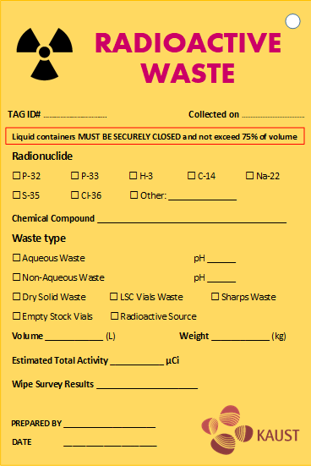
Figure 1. Radioactive Waste Tag

How to complete the radioactive Waste Tag
TAG ID# | Use this format: Ryy-Month-#  Example: A carboy of P-32 aqueous waste is ready for collection and the waste is prepared on 4-Mar-2023, the unique Radioactive Waste Tag ID number will be: R23-Mar-01. If there are a second waste bag of H-3 dry waste to be collected on the same day the waste bag will have the following Radioactive Waste Tag ID: R23-Mar-02
Collected on | Pick-up date
Radionuclide | Select the correct radionuclide.
Chemical compound | Chemical components
Waste type | Select the correct type according to specifications detailed in this SOP.
pH | Indicate the pH number if waste is aqueous (should be in this range 6-10)
Volume (L) | Total volume of the liquid waste in the carboy
Weight (kg) | Total weight of the dry solid waste
Estimated total activity | Indicate the Total Activity which will be the sum of the activity indicated in the associate Radioactive Accumulation Waste Log. Please ensure you indicate the unit.
Wipe survey results | Indicate the results of the wipe survey and units. The survey must be done with the appropriate instrument methods (i.e. either using the Liquid Scintillation Counter or a survey meter).
Prepared by | Person preparing the bag/container for disposal and collection by the RSO.
Date | Preparation date

Appendix 4 – Radioactive Waste Accumulation Log
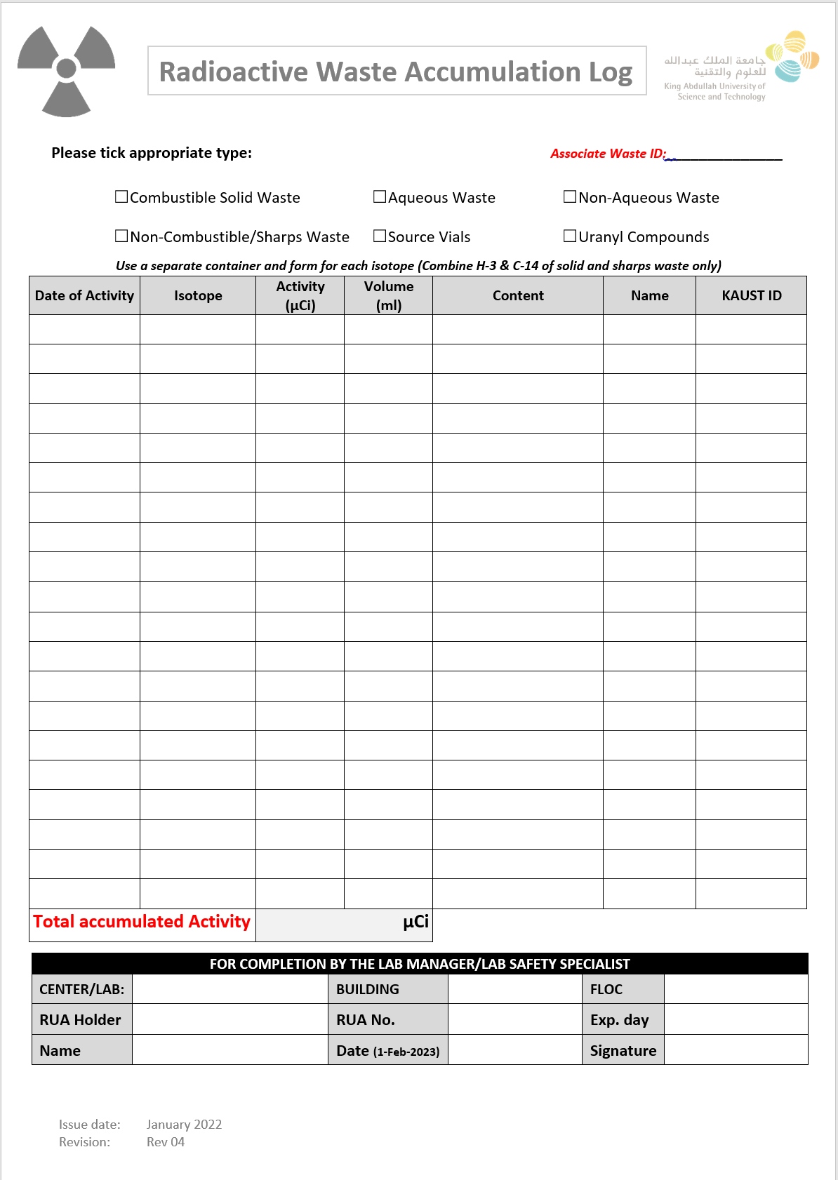

Appendix 5 – Radioactive Waste Pick-Up Request Form
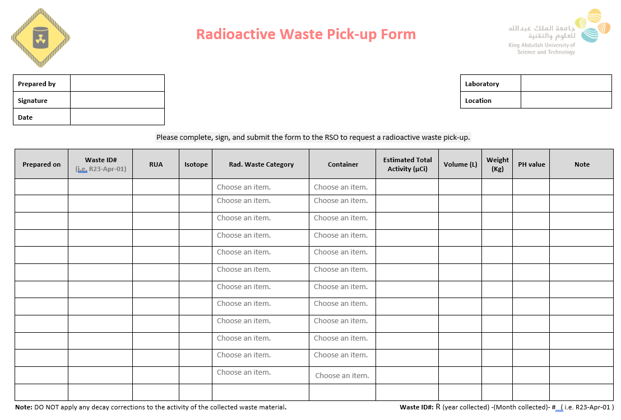

Appendix 6 – List of Items for Waste Management Available at the Chemical Warehouse
SAP Number | Description | Picture
3000008274 | HDPE Natural Jerrycan with screwcap  5 L | 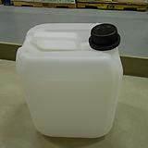
3000008275 | HDPE Natural Jerrycan with screwcap  10 L | 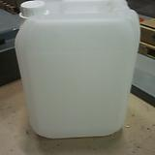
3000003858 | Glass bottle  500 ML | 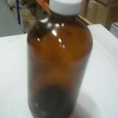
3000003921 | Glass bottle  32OZ (0.9 liters) | 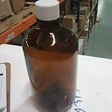
3000006921 | Secondary tray - Akro Mils Inctotes Gray | 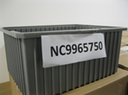
11378083 | Cable ties, clear 200mm (PACK OF 100) | 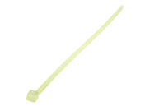
11338093 | Cable ties, clear 300mm (PACK OF 100)

