Please select and print the sign that corresponds to the laser class
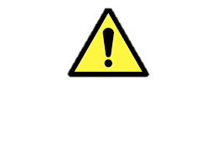
CAUTION
Class 2 Laser In Use
Laser Radiation - Do not stare into beam.

Diode laser, 670 nm
Maximum Power: ## mW
Laser Safety Contact (Lab) | XXXX |  | 808 XXXX | 05X XXX XXXX
Laser Safety Contact (LEM) | Ralph A. Timmermeester |  | 808 7582 | 054 470 0523
Laser Safety Specialist (HSE) | Moustafa Elsoubki |  | 808 5265 | 0546005994

CAUTION
Class 2M Laser In Use
Laser Radiation - Do not stare into beam or view directly with optical instruments.

Diode laser, 670 nm
Maximum Power: ## mW
Laser Safety Contact (Lab) | XXXX |  | 808 XXXX | 05X XXX XXXX
Laser Safety Contact (LEM) | Ralph A. Timmermeester |  | 808 7582 | 054 470 0523
Laser Safety Specialist (HSE) | Moustafa Elsoubki |  | 808 5265 | 0546005994

CAUTION
Class 3R Laser In Use
Laser Radiation – Avoid Direct Eye Exposure to Beam.

Diode laser, 670 nm
Maximum Power: ## mW
Laser Safety Contact (Lab) | XXXX |  | 808 XXXX | 05X XXX XXXX
Laser Safety Contact (LEM) | Ralph A. Timmermeester |  | 808 7582 | 054 470 0523
Laser Safety Specialist (HSE) | Moustafa Elsoubki |  | 808 5265 | 0546005994

